**Trip Planning Project**

**Note: Text in bold are additions from my side**

**Prepare Trip Database with following tables:**

User Trip Expense Traveller

U_id (P.K.) T_id (P.K.) E_id (P.K.) Tr_id (P.K.)

U_name T_name T_id (F.K.) T_id (F.K.)

U_mobile T_start_date U_id (F.K.) U_id (F.K.)

U_email T_end_date E_name

Password T_creator_id (F.K. (User (U-id))) E_category

age **T_route (F.K (Route (R_id)))** E_amount **T_trip_package(F.K (Trip_package(tp_id)))**

**Route Trip_package Destinations**

**R_id (P.K) tp_id (P.K) id (F.K(Trip_package(tp_id))**

**tp_title destination**

**R_start_point tp_duration**

**R_end_point tp_category**

**R_distance tp_cost**

**R_travel_mode tp_available**

**R_travel_duration**

**Route Table contains details for different routes.**

**Trip_packages contains travel destinations packag. Whereas trip table will contain details of the actual trip taken by a user for one or more travel packages**

**A traveler is a user who goes on a trip.**

**Queries on Tables of Trip Database for reports:**

1. Find total expense occurred by all travelers who travelled between 10-feb-19 and 15-feb-19.

Sol]

SELECT SUM(amount) 'Total', trip_id

FROM expense

WHERE trip_id IN (SELECT id FROM trip WHERE start_date BETWEEN '2019/02/10' AND '2019/02/15');

Output:

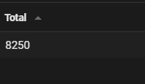

1. Find out number of times each user has travelled till date.

Sol]

SELECT u.name 'user', COUNT(tr.trip_id) 'No Of Times Travelled'

FROM traveller tr LEFT JOIN user u ON tr.user_id=u.id

GROUP BY tr.user_id

ORDER BY tr.user_id;

Output:

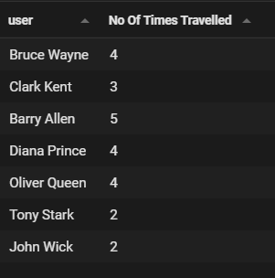

1. Find user wise trip details arranged in ascending order.

Sol]

SELECT tr.user_id, u.name 'Name', t.name 'Trip', tp.title 'Trip Package', tp.category, t.start_date, t.end_date, r.start_point, r.end_point, tp.duration

FROM traveller tr LEFT JOIN user u ON tr.user_id=u.id

LEFT JOIN trip t ON tr.trip_id=t.id

LEFT JOIN trip_package tp ON t.trip_package_id=tp.id

LEFT JOIN route r ON t.route_id=r.id

ORDER BY tr.user_id;

Output:

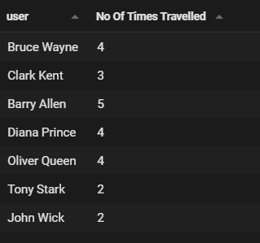

1. Find name of users who has spent more than 1 lac on their trips in year 2018.

Sol]

SELECT name, result.trip, result.start_date,Total FROM(

SELECT e.user_id, u.name, t.start_date, t.name 'Trip', SUM(e.amount) 'Total'

FROM expense e LEFT JOIN user u ON e.user_id=u.id

INNER JOIN trip t ON e.trip_id=t.id AND t.start_date LIKE '2019-__-__'

GROUP BY e.user_id) result

WHERE result.total > 4000;

Output:

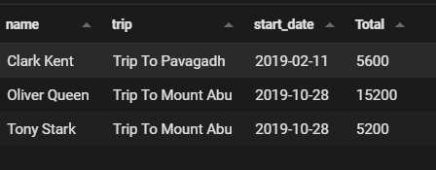

1. Find total amount spend by all users.

Sol]

SELECT u.name, result.total 'Total Amount Spent'

FROM (SELECT e.*, SUM(e.amount) 'total' FROM expense e GROUP BY e.user_id) result

LEFT JOIN user u ON result.user_id=u.id;

Output:

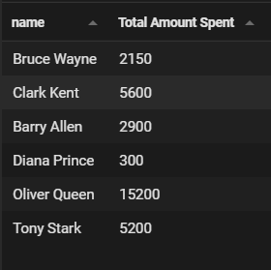

1. Find name of all users.

Sol]

SELECT name FROM user;

Output:

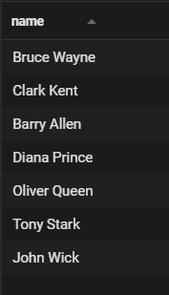

1. **Find expense details for all users by categories**

Sol]

SELECT u.name, category, SUM(amount) 'Amount'

FROM expense e LEFT JOIN user u ON e.user_id=u.id

GROUP BY user_id, category;

Output:

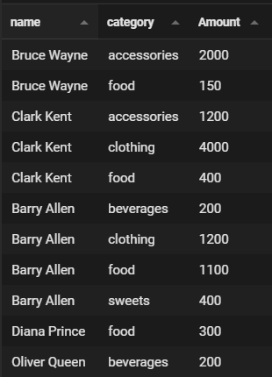

1. Find the total amount spent by all users for expense category “food”.

Sol]

SELECT SUM(e.amount) 'Total Amount For Food'

FROM expense e WHERE e.category='food';

Output:

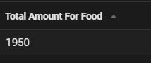

1. Find total number of trips before 1-jun-19.

Sol]

SELECT COUNT(t.id) 'No Of Trips Before 1-Jun-19'

FROM trip t WHERE t.start_date < '2019-06-01';

Output:



1. Find in which year users have travelled for trips.

Sol]

SELECT u.name 'User', t.name 'Trip', YEAR(t.start_date) 'Year'

FROM traveller tr LEFT JOIN trip t ON tr.trip_id=t.id

LEFT JOIN user u ON tr.user_id=u.id

GROUP BY t.id;

Output:

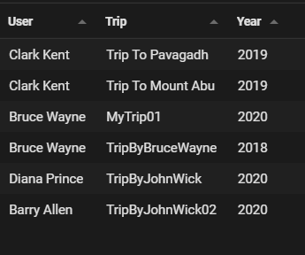

1. **Find total trips based on trip category; for eg No of Trips for category Adventure.**

**Sol]**

SELECT tp.category 'Trip Categpry', COUNT(tp.category) 'Total Trips'

FROM trip t LEFT JOIN trip_package tp ON t.trip_package_id=tp.id

GROUP BY tp.category;

Output:

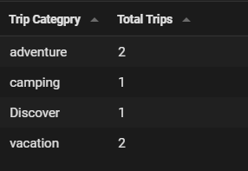

1. **Find No of users for each type of trip.**

**Sol]**

SELECT tp.category 'Type Of Trip', COUNT(category) 'No Of Trip'

FROM traveller tr LEFT JOIN trip t ON tr.trip_id=t.id

LEFT JOIN trip_package tp ON t.trip_package_id=tp.id

GROUP BY tp.category;

Output:

